South Florida Algal Bloom Sampling Results - May
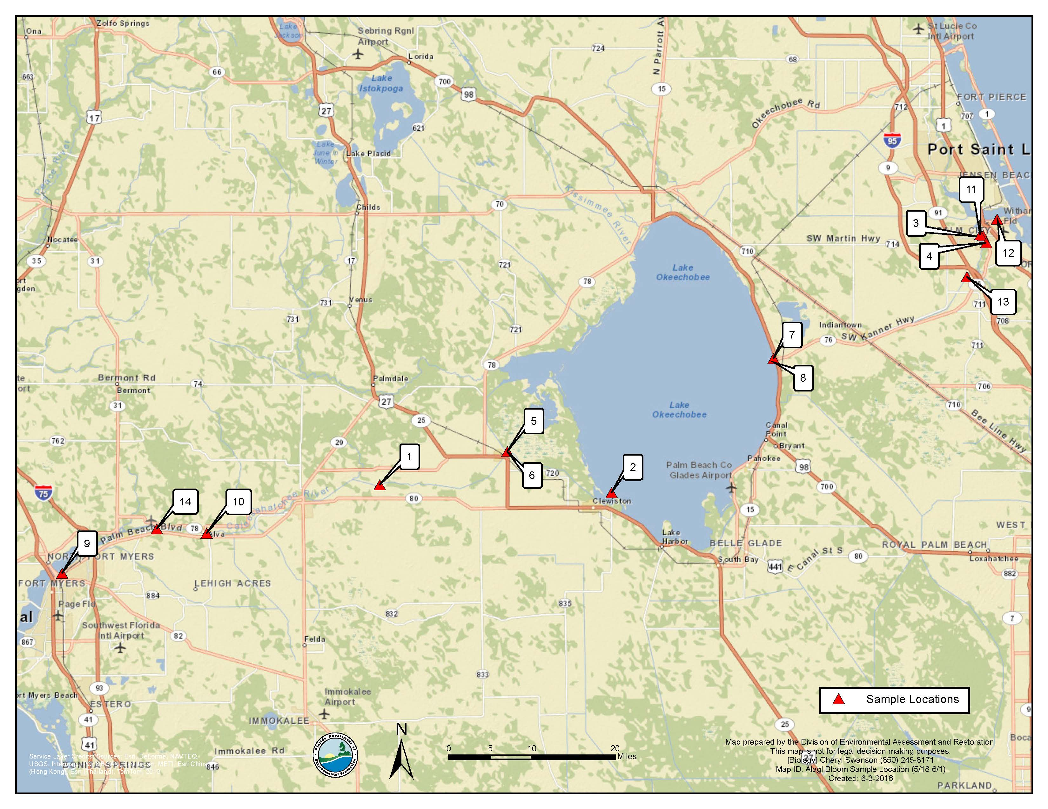
Sample Date | Samples Collected By | Samples Analyzed By | Sampling Location  (Latitude and Longitude) | Depth | Algae ID  (Type of Blue Green Algae) | Microcystin Toxin (measurement in micrograms per liter)
6/1/2016  (14) | FDEP | FDEP | Lee County  Caloosahatchee River, W.P. Franklin Lock & Dam (N 26° 43' 15", W -81° 41' 33") | 0.3 m | mixed algae; no dominant species in sample | not detected
5/31/2016  (13) | SFWMD | FDEP | Martin County  St. Lucie Locks C44S80 Upstream Surface (N 27° 06' 41.78", W -80° 17' 06.04") | 0.3 m | mixed algae; no dominant species in sample | not detected
5/31/2016  (12) | FDEP | FDEP | Martin County  St. Lucie River Central (N 27° 12' 3", W -80° 13' 58") | 0.3 m | mixed algae; no dominant species in sample | not detected
5/31/2016  (11) | FDEP | FDEP | Martin County  St. Lucie River S. Fork (N 27° 10' 36", W -80° 15' 42") | 0.3 m | mixed algae; no dominant species in sample | not detected
5/24/2016  (10) | FDEP | FDEP | Lee County  Alva Boat Ramp @ Josephine St. | 0.3 m | Dominant taxon: Microcystis aeruginosa | 27.3 µg/L
5/24/2016  (9) | FDEP | FDEP | Lee County  Billy's Creek at SR 80 | 0.3 m | no dominant | not detected
5/23/2016  (8) | SFWMD | FDEP | Martin County  Lake Okeechobee - Port Mayaca S 308 C Upstream Lake Side  N 26° 59' 6"  W -80° 37' 16.5" | Water column | Dominant: Microcystis aeruginosa | 24.4 µg/L
5/23/2016  (7) | SFWMD | FDEP | Martin County  Lake Okeechobee - Port Mayaca S 308 C Downstream Canal Side C-44  N 26° 59' 6"  W -80° 37' 16.5" | Water column | no dominant | 5.1 I µg/L
5/23/2016  (6) | SFWMD | FDEP | Glades County  Moore Haven - S77 Rim Canal Upstream Lake Side  N 26° 50' 26.16"  W -81° 5' 0.72" | Water column | no dominant | not detected
5/23/2016  (5) | SFWMD | FDEP | Glades County  Moore Haven - S77 Downstream C43 Canal Side  N 26° 50' 26.16"  W -81° 5' 0.72" | Water column | no dominant | not detected
5/19/2016  (4) | FDEP | FDEP | Broward County  St. Lucie River S. Fork near Veteran's Memorial Bridge  N 26° 9' 50.9394"  W -80° 15' 5.6154" | Water column | Dominant: Microcystis aeruginosa | 2.5 I µg/L
5/19/2016  (3) | FDEP | FDEP | Martin County  St. Lucie River Riverwatch Marina  Not provided  Not provided | Water column | no dominant | not detected
5/18/2016  (2) | FDEP | FDEP | Hendry County  Lake Okeechobee near Channel Marker 9B  N 26° 46' 36.6954"  W -80° 54' 8.676" | Water column | Co-dominant taxa: Microcystis aeruginosa and Dolichospermum circinalis | 1.5 I µg/L
5/18/2016  (1) | FDEP | FDEP | Glades County  Caloosahatchee River, Ortona Lock  N 26° 47' 21.3966"  W -81° 18' 19.1808" | Water column | no dominant | not detected

